# Extending the Brams-Kilgour Model Linking Partisan Imbalance in Non-Competitive States to Outcomes in the Electoral College: Historical Data from 1868 to 2016*

# Jonathan Cervas Bernard Grofman

# School of Social Sciences, University of California, Irvine

# May 5, 2017

# *Work on this project was supported by the Jack W. Peltason (Bren Foundation) Chair at the University of California, Irvine. The first named author is a graduate student in political science at the University of California, Irvine. The second named author is a Professor of Political Science at UCI and the Peltason Chair of Democracy Studies. The contact for this paper is Jonathan Cervas <JCervas@uci.edu>.

# ABSTRACT

**TBA once we know what the data actually show**

The Electoral College (EC) is often criticized because the logic of campaigning under the EC’s weighted voting rule makes each party’s presidential campaign focus exclusively on *battleground states*, i.e., states characterized as competitive. Such states can, over the course of a campaign, “swing” toward one candidate or the other. Often such states are taken –wrongly as we shall see -- to be the ones that are determinative of the presidential winner. Even fewer states, the largest of the battleground states in terms of EC votes, are often seen as especially critical, while a large majority of states have seemingly no power to determine the president since, for all practical purposes, the outcomes in those states cannot be changed by the presidential campaign.  It is also well known that it is the potentially pivotal states that get all the attention from the candidates and the media.

The view that the states which are non-competitive are therefore made irrelevant has been challenged by Bram's and Kilgour (2017). These authors point out that each candidate’s electoral votes can be thought of as coming from two sources: noncompetitive states—with outcomes effectively decided before the election—and the competitive states that support him or her on election day. Thus, the readily foreseeable outcomes in non-competitive states can create a “loading of the dice” in an election, by requiring the candidate with fewer expected easy victories to do remarkably well in the more competitive states in order to win. For example, in 2012, Brams and Kilgour point out (p. 101): “Because Barack Obama had a 233–191 electoral vote lead over Mitt Romney in the 42 noncompetitive states and the District of Columbia, he needed only 37 of the 114 electoral votes in the competitive states to win with a majority of 270 electoral votes, whereas Romney needed 79.” Indeed, at the extreme, we can imagine the outcomes in states essentially safe for one party might involve enough votes so as to render outcomes in the more competitive states the ones that are irrelevant.

Brams and Kilgour specify an indicator, *Winningness*, of the extent to which the virtually certain outcomes in non-competitive states structure the expected outcome of the overall election in a two candidate contest. If we, for simplicity, posit that each of the battleground states is equally likely to go for either candidate and there are b such states, then *Winningness* is the proportion of the 2b combinations of zeroes and ones in which the candidate who is ahead in the non-competitive states is the winner (adding the seats won in competitive states found in that particular combination to the already “known” votes in the non-competitive states). Note that the greater the advantage a given candidate has in the non-competitive states the greater will be the expected proportion of the 2b outcomes in which that candidate is the winner of an Electoral College majority, since the candidate ahead in seats won in non-competitive states will need fewer seats won from the competitive seats to amass a winning majority than will the other candidate. In 2012, with 8 competitive states, Brams and Kilgour point out (p. 101) that 207 (80.9%) of the 256 splits would result in a win for Obama, whereas only 49 (19.1 %) would result in a win for Romney, giving Obama 4.22 times more ways of winning than Romney.”

Brams and Kilgour (2017: 101-2) offer two other closely linked indicators that can be used to measure the extent to which outcomes are predictable: *Vulnerability* and *Fragility*. *Vulnerability* is defined as “the proportion of the coalitions in competitive states in which a single competitive state, by switching to the other candidate, either can cause a change in the winner or create a tie …;” while “*Fragility* is measured by the expected number of competitive states in a winning coalition that can disrupt victory in this way.”

Brams and Kilgour, using a definition of *non-competitive state* as one where the winner’s vote share is expected to be above 53%, calculate *Winningness*, *Vulnerability*, and *Fragility* for four recent elections: 2000, 2004, 2008, and 2012.  In the next section we extend their analysis to include all 38 presidential elections in the modern two-party era, from 1868-2016.  We look at the correlations of their measures over the entire time period **JONATHAN TO PROVIDE** and we consider how well each (and all three together) allow us to predict EC winners and EC seat shares in these 38 elections. **JONATHAN TO PROVIDE** In that section we also consider how analyses would change if we changed the definition of non-competitive state **JONATHAN TO PROVIDE**, and we discuss the question of how well an *ex post* measure of non-competitive states relates to expectations about non-competitiveness *ex ante*. **JONATHAN TO PROVIDE**

In the succeeding section we offer a simple alternative measure, based on the Brams and Kilgour intuition about the importance of the imbalance in partisan breakdown of EC seat shares in the non-competitive states. We show that this measure, when coupled with an indicator of the proportion of EC votes that are found in the non-competitive states, is even more highly predictive of the final EC outcomes and EC seat percentages than any of the measures proposed by Brams and Kilgour. **JONATHAN TO PROVIDE**

**II. *Winningness*, *Vulnerability*, and *Fragility*: 1868-2016**

We show in Table 1 *ex post* values for the Democratic and Republican EC seat shares in the noncompetitive states in the first two columns, **JONATHAN THE FIRST TWO COLUMN HEADINGS IN IT ARE MISLEADINGLY LABELED PROBABLY BEST TO MAKE THIS CLEAR IN THE TABLE NAMES, E.G., DATA ON NON-COMPETITIVE SEATS OUTCOMES AND ON OUTCOMES** and we show the final EC seat tallies for both parties, both as numbers, and then, for the Republicans, as a percentage.[1] In addition, we provide a column that has the *difference* between the Democratic and Republican EC seat shares in the noncompetitive states, and a further column that shows that difference normalized by total EC seats.[2] We show in Table 2 and Figure 1 values of *Winningness*, *Vulnerability*, and *Fragility* for the Electoral College entire modern two-party era, 1868-2016.

**<< Tables 1 and 2, ~~and Figure 1~~ about here>>**

We see from **Table 2 that. in the majority of years, *winningness* is such that the outcome is expected to be determined solely by what happens in the non-competitive states, i.e., a winningness values of zero or one. In the four elections analyzed in Brams and Kilgour (2017), only one, 2008, fell into this category. Had Brams and Kilgour extended their data back somewhat further in time, however, they would have found that in each of the five immediately previous elections one of the two candidates had locked up enough votes in non-competitive states to win the election.**

**Note also that when *Winningness* is exactly 1 or exactly 0 then *Vulnerability* is not defined, and thus *Fragility* is not defined. JONATHAN THERE IS A PROBLEM WITH TABLE 2. IT IS SHOWING VULNERABILITY VALUES FOR some cases of WINNINGNESS =1 (WI NNINGNESS FOR THE OTHER PARTY =0). But that can’t happen, since if winningness =1 then what happens in the competitive states has no impact on the outcome and thus no changes in the competitive states can matter!!**

While the various measures proposed by Brams and Kilgour (2017) are of theoretical interest, in and of themselves, we are most interested in how these measures allow us to address the bias imposed on likely Electoral College outcomes of having a substantial proportion of seat outcomes already known in advance in a fashion that favors one political party. Brams and Kilgour note (2017: 111) that the sign on the Winningness advantage correctly predicts the winners in all four of the presidential contests they study. When we replicate that analysis for all 38 elections we find that this holds for all but two elections: 1880 and 1960. If we consider just the 17 elections where the winner was determined by the competitive states, this is a **success rate of 88%**. While these two elections were very close in two-party vote margin, and thus might be regarded as hard to predict, they were less so electorally. In 1960, John F. Kennedy won the electoral vote by 9.1% and in 1880, James Garfield won by 7.5%.[3] **JONATHAN HAVEN’T WE IN OUR OTHER PAPER TALKED ABOUT THESE TWO ELECTIONS and shown that SMALL MARGINS IN A FEW STATES DECIDED THINGS. I THINK THE fSENTENCES IMMEDIATELY ABOVE SEEM TO CONTRADICT OTHER STUFF WE’VE WRITTEN.**

A more difficult test for the predictive usefulness of *Winningness* **and the other two variables i**s to ask how well **they, singly or collectively***,* predict final EC seat share outcomes.Table 3 looks at the correlations among the *Winningness*, *Vulnerability*, and *Fragility* variables, and EC seat share. **For *Vulnerability*, and *Fragility* we must report results separately for the Republicans** **and the Democrats**. **For *Winningness* it does not really matter which party we analyze since we are doing all analyses in terms of the two party vote, and thus the *Winningness* value for the Democratic candidate is simply the neegative of the *Winningnes*s value for the Republican candidate, but for comparability with the two variables defined only for particular parties, we also report *Winningness*  values both for the Republican and for the Democrat. *Winningness* is defined for all elections, so that we can run its correlation with the EC outcome for the entire data set. But the other correlations reported in Table 3 are only for values of *Vulnerability* and *Fragility* that are defined, i.e., for the elections whose outcomes can be effected by what happens in the competitive states (17/38).**

**We see from Table 3 that, as commonsense would predict, when *Winningness* is high, *Vulnerablity* and *Fragility* are both low. The correlation between Republican *Vulnerability* and Republican *Fragility* is .XX , that between Democratic *Vulnerability* and Democratic Fragility is .XX As also expected, we find *Winningness* highly correlated with EC outcomes (r=0.90). ARE YOU SURE? THE SCATTERPLOT LOOKS MOrE SCATTERED THAN THAT. However, when we restrict *Winningness* to values between 0 and 1 (i.e., the values for which *Vulnerability* is defined), its correlation with EC outcomes declines to r=JONATHAN FILL IN When we restrict ourselves to the cases where *Winningness* values are neither zero nor one, *Vulnerability* is the most highly correlated single variable with the EC outcome for the Democratic candidates, but *Fragility* is the most highly correlated for the Republican candidates. .**

**<< Table 3 JONATHAN TO PROVIDE about here>>**

**We provide scatterplots between the three measures and the EC outcome in Figure 1. It is apparent from Figure 1a that the high proportion of cases for which *Winningness* is either 0 or 1 limits its power to predict final seat shares as opposed to simply predicting the winner. Jonathan for *Vulnerability* and *Fragility* you need to show separate scatterplots for each party. THERE’S IS SOMETHING WRONG FOR THE LAST TWO SCATTERPLOTS. THEY ARE SHOWING TOO MANY CASES!! There should only be 17!**

**<< Figure 1 JONATHAN TO PROVIDE about here>>**

**scatterBrams.pdf**

**Because *Vulnerability* and *Fragility* seem likely to add predictive power about EC outcomes above and beyond *Winningness*, we report in Table 4 JONATHAN, WHAT I WAS TAUGHT WAS THAT A REGRESSION WITH MORE THAN ONE INDEP VARIABLE IN IT IS A MULTIVARIATE REGRESSION AS OPPOSED TO A BIVARIATE REGRESSION WHICH HAS ONLY ONE INDEP VARIABLE AND ONE DEPENDENT ONE. THAT LABELING PRESERVES SYMMETRY OF FORMULATION, BUT YOU ARE RIGHT THAT THE WORLD HAS MOVED ON! AND NOW, RATHER MISLEADINGLY IN MY VIEW, THE NOMENCLATURE IS THAT A REGRESSION WITH MULTIPLE INDEPENDEN VARIABLES IS A MULTIPLE REGRESSION, AND ONY A FANCY REGRESSION WITH MULTIPLE DEPENDENT VARIABLES GETS CALLED A MULTIVARIATE REGRESSION regressions with all three as independent variables, one to predict Democratic candidate EC shares, one to predict Republican candidate EC shares JONATHAN TO PROVIDEWe find JONATHAN FILL IN**

**<< Table 4 about here JONATHAN I THINK WE NEED ONE REGRESSION to predict Democratic candidate EC shares, one to predict Republican candidate EC shares >>**

**<< Table 4 about here>>**

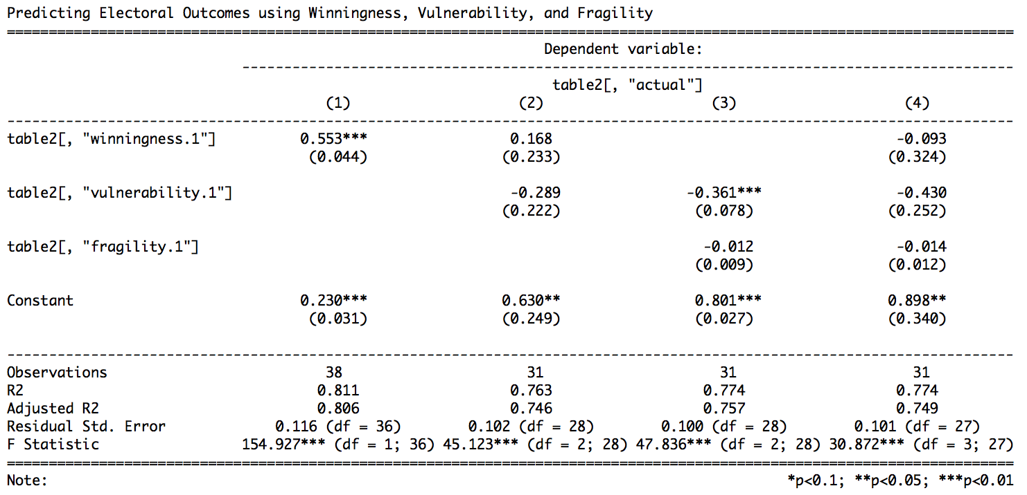

*How analyses would change if we changed the definition of non-competitive state* **JONATHAN TO EXPAND**

Brams and Kilgour (2017: **110-111**) discuss their choice of the domain of competitiveness as plus or minus three percentage points of two-party vote.  One justification for this choice of range is a pragmatic one: there are computability issues in that, when we expand the range of competition, we have many more combinations to analyze. But there is also a theoretical reason to favor this choice: for this range, the assumption they use that all states in this range had an *a priori* equal probability of being won by either party seems plausible.  Nonetheless, it is useful to consider the robustness of their measures to alternative specifications of the range used to define a competitive seat. In Table 5, for the four elections they consider and also for 2016, we show the comparisons between the values they derive for a plus or minus three percentage points definition and the more conventional plus or minus five percentage points definition of a competitive state.

Increasing the number of states defined as competitive does not give any expectation of a monotonic change in the three variables. It’s possible that the new states are more (less) vulnerable or more (less) fragile than those previously included. Likewise, while a candidate might do especially well in the most competitive states, the differing electoral values of states that are less competitive might change the ratio of coalitions they might be expected to win. For instance, if a large state is just outside the competitive range under the narrow definition, but enter the coalitions under the less restrictive definition, it could increase the number of coalitions wins for the disfavored party, but not change anything for the leading candidate. **In both 2000 and 2016, years in which the popular vote and the Electoral College, the candidate with the higher *Winningness* is no longer the winning candidate in the election, when we change the definition of competitive state.**

**<< Table 5 about here JONATHAN TO PROVIDE >>**

**From Table 5 we see JONATHAN FILL IN**

*Accuracy of ex post classification of states as non-competitive*

Changing the states that are considered competitive changes which states are not considered competitive, and therefore changes the number of seats from the competitive states a party needs to win the election. In the parlance of Banzhaf (1968), we might say it changes the *quota*, or the number of EC seats a candidate needs to win.

Whereas Obama had enough EC seats in the non-competitive states in 2008 using the plus or minus 3% definition, [4] he was twelve seats shy of victory using the less restrictive plus or minus 5% definition. While Obama remained the favorite even when we expand the definition of competitive states, under the former definition, Obama’s *quota* is effectively zero in the competitive states, while under the latter definition it becomes twelve.[5]

**The 2016 election works in the opposite direction from 2008. When we switch from a plus or minus 3 percentage point definition of competitive to a plus or minus 5 percentage point definition of competitive, a 2016 election previously characterized as close now is seen as less close.** Using Brams and Kilgour’s definition of competitive, Donald Trump had a one seat EC lead in non-competitive states, and by virtue of winning the majority of the competitive EC seats, won the election. Using the more traditional plus or minus 5%, Clinton would had have a 50 EC seat advantage, having 182 safe EC seats **to** Trump’s 132. *Winningness* would have predicted a Clinton victory and, given the size of the *Winningness* score (0.77), she would be predicted to win by a large margin.[6] **Of course, as we know from polling, all predictions have a margin of error, and the fact that we might give high odds that a given candidate will win does not mean that her election is a certainty.**

**While the analyses above show that our choice of range to define a competitive state can matter a great deal, to maximize our compatibility with Brams and Kilgour (2017), and because we think this definition is a plausible one in the context of our attempts at predicting EC outcomes, we will continue to use the Brams and Kilgour (2017) plus or minus 3 percentage point definition of competitive state in the rest of the essay.**

**III. An Alternative Way to Make Use of Partisan Imbalance in Non-Competitive States to Predict EC Outcomes**

We, like Brams and Kilgour (2017), believe that outcomes in non-competitive states are critical in understanding final Electoral College winners. In this section we capitalize on that insight by offering two simple measures that we show jointly performs as well or better as the Brams-Kilgour variables in predicting final EC outcomes.

To present our measure, some notation is useful. We may partition the states into the set of competitive states, Cj and the set of non-competitive states, NCi. The EC seats in a competitive state are labeled as s(Cj) and the EC seats in a non-competitive state are labeled as s(NCj). We have s(EC) = s(Cj) + s(NCj). The noncompetitive states won by Democrats we label NCD, and the non-competitive states won by Democrats we label NCR. The seats in the non-competitive states won by the Democrats are thus labeled s(NCD) and the seats in the non-competitive states won by Republicans are thus labeled s(NCR).

We will be interested, on the one hand, on the partisan balance of seats in the non-competitive states and, on the other hand, on the share of the states that fall into the non-competitive category. We define our first variable of interest as the difference between the two-candidate’s non-competitive electoral totals, divided by the total number of EC seats

*Non-Competitive Advantage* = [s(NCD) -s(NCR)]/s(EC)

This measure is standardized, thus allowing us to compare its effects across elections.  The intuition is simple, when one party has a big advantage in non-competitive electoral votes, they will be more likely to win the election.   Bram's and Kilgour reflect this intuition by examining coalitions among competitive states, and determining outcomes under the explicit assumptions that the competitive state outcomes occur independently of one another and with an equal probability of victory for the two parties in each.  We do not require either of these strong assumptions.[7]  But exactly the same intuition drives our model as that in the work of Brams and Kilgour, namely that the candidate that has a bigger advantage in electors from the non-competitive states will have more options in terms of possible wins in competitive states leading to Electoral College victory.

The second variable we propose is even more intuitive. It is simply the proportion of non-competitive seats. The more seats that are determined in advance, because they fall into the non-competitive category, the more predictable, *ceteris paribus*, should be the winner. At one pole, if there are enough seats in the non-competitive states so that the party with most of them already has an Electoral College majority, then the election is already over except for the determination of the winning candidate’s final total.[8] At the other pole, if the non-competitive state EC vote shares are perfectly evenly divided between the parties, then the election is determined solely by the outcomes in the competitive states.

We first test the predictive usefulness of our *Non-Competitive Advantage* variable by looking to see how often the party with the advantage in the non-competitive states wins the EC vote. We will model this **using the Brams and Kilgour plus or minus 3% definition of competitive state. As does the *Winningness* measure, in all four of the elections from 2000 through 2012, *Non-Competitive Advantage***correctly predicts the presidential outcome. **Indeed, we find that in just 5 of the 38 elections does the party with a *Non-Competitive Advantage* not go on to win the election! JONATHAN IS THIS RIGHT for the 3% value??!! THIS ACTUALLY IS A SLIGHTLY WORSE PERFORMANCE THAN THE WINNINGNESS MEASURE. In all but** JONATHAN FILL IN **of these elections, the partisan gap in competitive seats is very low, and thus the election is hard to predict. JONATHAN IS THIS RIGHT for the 3% value??!!**

Next, we regress Republican EC seat share on the *Non-Competitive Advantage* variable*.* Here we find (see Table 6) **a very strong and significant relationship between the two measures, and the simple regression between them yields an adjusted R2 of .73. We compare this regression with one that models actual EC seat share with *Winningness*.**which is considerably higher than the highest correlation we found for any of the Brams-Kilgour variables. **JONATHAN IS THIS RIGHT? JONATHAN YOU FOUND EARLIER THAT there is a near perfect correlation between the number of safe ecvotes and the seat share for the party; both around 0.90 (-0.90), and both statistically significant.  Additionally, there is a .976 correlation between the difference in non-competitive ecvotes and the final seat share. IF THESE NUMBERS STILL HOLD FOR THE MEASURES I USE PLEASE FILL IN ACCORDINGLY.**

**<<Table 6 about here>>**

However,we are also aware that the expected relationship might not be linear. Thus, we also regress the log odds of Republican seat share on the log odds of Non*-Competitive Advantage*.Now we find (see Table 6) JONATHAN **FILL IN**

In Table 4 we previously looked at a multiple regression including all three Brams-Kilgour variables. Now we do a comparable regression, using both the *Non-Competitive Advantage* variable and the proportion of competitive seats variable as our independent variables, with Republican EC seat share as the dependent variable. Here we find (see Table 4) J**ONATHAN FILL IN** Thus, we see that we do better in predicting final outcomes using our two variables than we do from using the three variables from Brams-Kilgour (2017), though both sets of variables are based on the basic Brams-Kilgour intuition about the importance of the EC outcomes in the non-competitive states. J**ONATHAN is this right??!**

Next we redo this multiple variate regression in log-odds terms, taking the log odds of Republican seat share as our dependent variable and using as our independent variables the log odds of *Non-Competitive Advantage* variable and the log odds of the proportion of competitive seats Now we find (see Table 4) J**ONATHAN FILL IN**

**IV. Discussion**

**TBA once we know what the data actually show**

**Table 1: Electoral College Data 1868-2016**



JONATHAN, NEEDS TO BE RELABELED AS TABLE 2

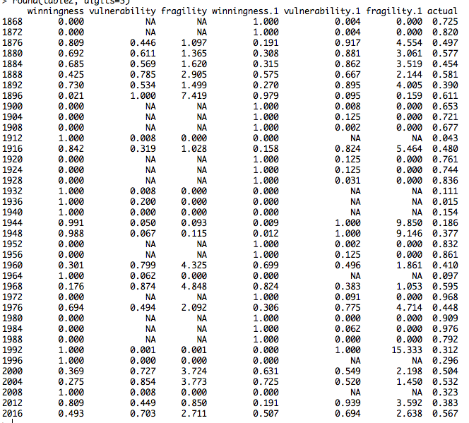

Note: placeholder for now. First three are the dems, second three are the reps, actual is rep percentage of ec

**Table 3: Correlations among the *Winningness*, *Vulnerability*, and *Fragility* variables for the Republican and Democratic Parties and with Republican EC seat share: 1868-2016** **JONATHAN TO PROVIDE**

**Table 4: Regressions with *Winningness*, *Vulnerability* and *Fragility* and Other Variables to Predict final Republican EC seat share** **JONATHAN TO PROVIDE**

**Table 5: Comparisons of Results for the *Winningness*, *Vulnerability*, and *Fragility* Variables for the Republicans for a Plus or Minus Three Percentage Point and a Plus or Minus Five Percentage Point Definition of *Competitive State*: 2000-2016** **JONATHAN TO PROVIDE**

**Table 5: Regressions with *Competitve* and Other Variables to Predict final Republican EC seat share** **JONATHAN TO PROVIDE**

Figure 1: Scatterplots for the *Winningness*, *Vulnerability*, and *Fragility* variables and EC seat share

*scatterBrams.pdf*

Figure 1: *Winningness*, *Vulnerability*, and *Fragility* variables for the Republicans and Republican EC seat share: 1868-2016

**JONATHAN TO PROVIDE in THE FORM OF A LINE CHART SO THAT WE CAN SEE THE OVERTIME TRENDS IN ALL FOUR. JONATHAN MAYBE WE SHOULD ALSO PUT IN EC SWING HERE—OR MAYBE SAVE THAT VARIABLE FOR THE OTHER PAPER? CAN YOU STICK IT IN SO WE CAN SEE HOW CORRELATED THE PATTERNS LOOK == THEN LATER WE CAN ALWAYS TAKE IT OUT.**

# References

Brams, Steven J. and D. Marc Kilgour. (2017). Paths to victory in presidential elections: the setup power of noncompetitive states. *Public Choice* 170:99–113,

Election 1984. (1984). *Editorial research reports 1984* (Vol. II). Washington, DC: CQ Press. Retrieved from <http://library.cqpress.com/cqresearcher/cqresrre1984091400>

1. In the process of replicating the Brams and Kilgour (2017) analyses we found a few minor errors that we corrected; those corrections explain the differences in the numbers reported in Table 1 for the elections of JONATHAN FILL IN and those reported in Brams and Kilgour, Table **JONATHAN FILL IN**.
2. To deal with the problem that there were some elections in which there were third parties with EC votes, we **JONATHAN PLEASE FILL IN HOW YOU DEAL WITH THIS complication, YEAR BY YEAR, FOR WHENEVER THIS PROBLEM EXISTS. BG, WE ARE IGNORING THE PROBLEMS OF THIRD PARTY BY ONLY CONSIDERING THE TWO-PARTY VOTE… SHOULD WE DO SOMETHING DIFFERENT? JONATHAN WE need a footnote explaining what we did and which years this might cause a problem**
3. In neither election were third party candidacies detrimental to either party.
4. Few would, at the time, have believed that the outcome was certain. McCain did not; he raised and spent over $300 million dollars in his quest for the presidency, though considerably outspent by Obama**.** McCain raised $368 million to Obama’s $730 million, http://www.opensecrets.org/pres08/
5. Since we decreased the number of non-competitive states in 2008 by changing the definition, we have also increased the number of competitive ones, from 102 to 159.
6. As we all know, Hillary Clinton won the popular vote by over 3 million votes, but lost the Electoral College.
7. We regard both of these assumptions as quite reasonable ones to make for purposes of model tractability, but we might expect that they would be falsified if there are electoral tides that sweep in a particular direction and affect states in a more or less uniform fashion, at least in percentage point terms (*uniform swing*). If competitive state outcomes are non-correlated with each other then we would expect that, taken as a whole, outcomes in the competitive states should also be uncorrelated with outcomes in the non-competitive states. We can test that assumption by correlating the Republican proportion of victories in the competitive states with the Republican proportion of victories in the non-competitive states, and correlating the Republican proportion of EC seat share in the competitive states with the Republican proportion of EC seat share in the non-competitive states. Doing so we obtain correlations of XXX and XXX, respectively, with statistical significances of XX and XX respectively. J**ONATHAN FILL IN**
8. In 1984, Ronald Reagan won 49 out of 51 states (including Washington D.C.) Norman Ornstein, writing before the election, said “Incumbent presidents don’t often lose, particularly presidents presiding over 6% real growth and low or non-existent inflation” (quoted in CQ Press, http://library.cqpress.com/cqresearcher/document.php?id=cqresrre1984091400}).